NAME: B.Poorvaja
REG NO:192473008
COURSE CODE: CSA0503
COURSE NAME: DATABASE MANAGEMNET SYSTEMS

PRACTICAL
EXP NO:6 SELECT with various clause – BETWEEN, IN, Aggregate function AIM:
To view the records from the tables using SELECT commands with BETWEEN, IN, Aggregate functions.

DESCRIPTION:
- The BETWEEN operator allows you to specify a range to test. We often use the BETWEEN operator
in the WHERE clause of the SELECT, INSERT, UPDATE, and DELETE statements.
- The IN operator allows you to determine if a specified value matches any one of a list or a sub query.
- MySQL provides many aggregate functions that include AVG, COUNT, SUM, MIN,
MAX, etc. An
aggregate function ignores NULL values when it performs calculation except for the COUNT function.
BETWEEN operator:
SELECTcolumn1,column2,... FROMtable_name
WHERE expr [NOT] BETWEEN begin_expr AND end_expr;
The expr is the expression to test in the range that is defined by begin_expr and end_expr. IN operator:
SELECTcolumn1,column2,... FROMtable_name
WHERE (expr|column_1) IN ('value1','value2',...);

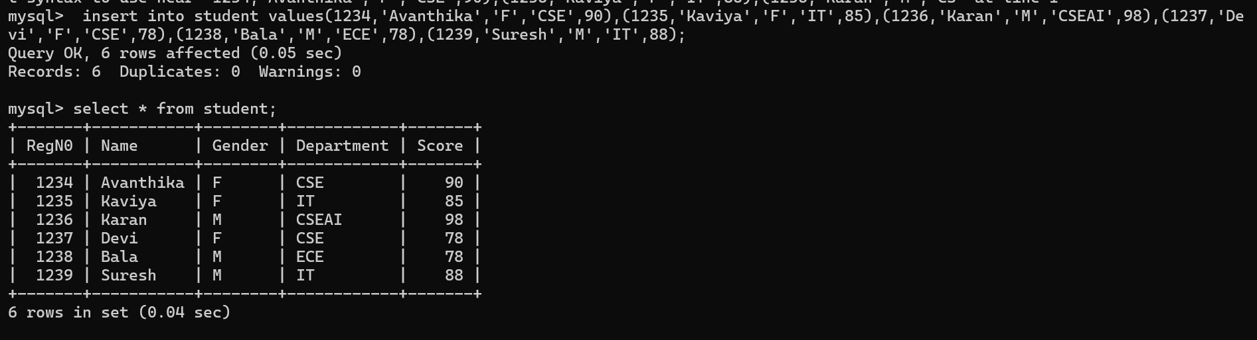
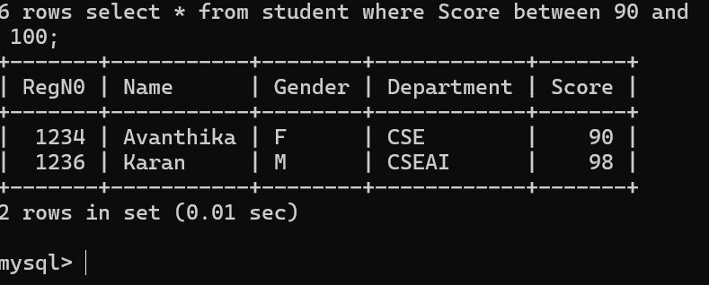
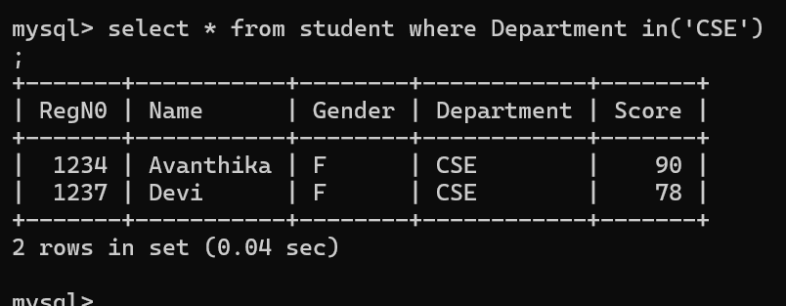

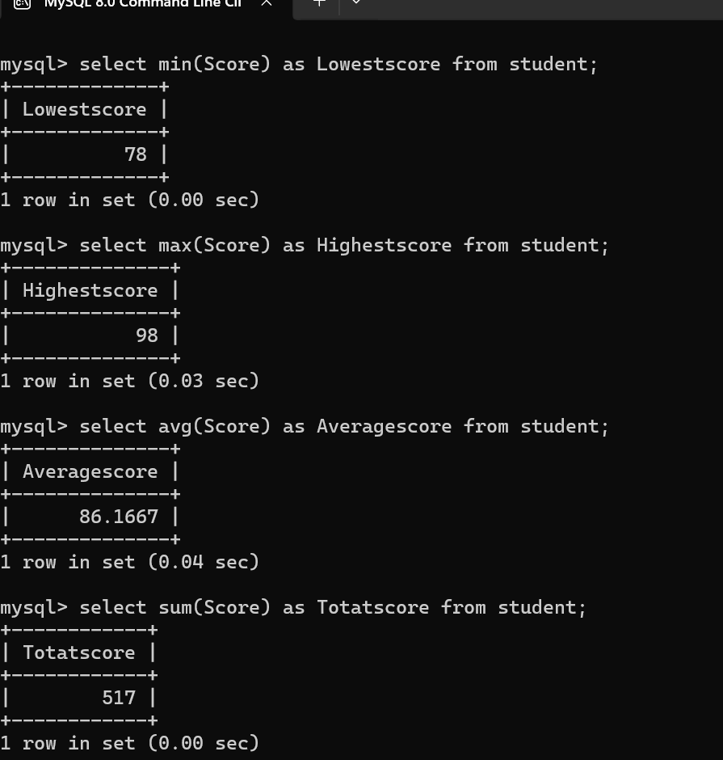

RESULT:
The records from the tables are displayed using SELECT commands with WHERE Clause and Pattern matching.

